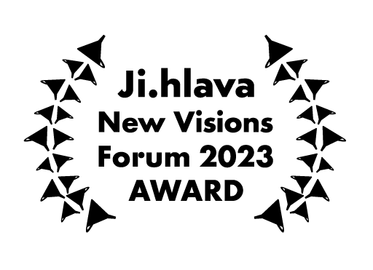
JI.HLAVA INDUSTRY 2023 – WINNERS

Ji.hlava New Visions Forum: Europe & U.S. Docs Awards

- UPP & SOUNDSQUARE AWARD
(post-production services in the value of 20,000 EUR)
  - If Pigeons Turned to Gold
    - Director: Pepa Lubojacki
    - Producers: Wanda Kaprálová, Klára Mamojková
    - Countries: Czech Republic, Slovakia
    - Jury statement:

We found this film to be brave, sincere, incredibly creative, and boldly experimental. It interrogates our paths in the world, the different paths inside one family, and the ways to exist beyond the ongoing pain of addiction. With this award, we want to reinforce Pepa's commitment to share this difficult story. This film will be an alchemical process, and it will need some excellent post-production support to hone its potential and vision.

- AMDOCS AWARDS
  - Valley of the Night (5,000 USD)
    - Director and producer: Lynne Siefert
    - Country: USA
    - Jury statement:

This is a stunning dive into a dystopian present, and we commend the filmmaker for her incredibly cinematic approach on such a relevant and pressing issue of these times. Introducing us to temporal migration with such poetic photography promises a very singular and fascinating film.

  - Vestibul (2,000 USD)
    - Director: Riley Hooper
    - Producers: Caitlin Mae Burke, Bryn Silverman
    - Country: USA
    - Jury statement:

This is a bold and uncompromising film that will create a new conversation around the agency we have with our bodies, sex, and pleasure. We want this award to encourage this filmmaker as she begins this filmic journey that will break taboos and empower many girls, women, and all the humans that need support in building a good relationship with their bodies.

- CURRENT TIME TV AWARD (2,000 USD)
  - You Never Just Walk Away
    - Director: Rozálie Kohoutová
    - Producer: Martina Knoblochová
    - Country: Czech Republic

- FILMAID AWARD (2,000 USD)
  - The Ferryman
    - Director: Pavlo Dorohoi
    - Producer: Olha Symonenko
    - Country: Ukraine

- #DOCS CONNECT TASKOVSKI TRAINING AWARD
  - Society
    - Director: Thomas Østbye
    - Producer: Ellen Ugelstad
    - Countries: Norway, Indonesia

- CANNES DOCS – MARCHÉ DU FILM AWARD
  - Women Walk Home
    - Director: Stephanie Andreou
    - Producer: Adrián Gutiérrez
    - Country: Cyprus

- DAE AWARD
  - Women Walk Home
    - Director: Stephanie Andreou
    - Producer: Adrián Gutiérrez
    - Country: Cyprus

- EFM AWARD
  - Barbara Hammer Project
    - Director: Brydie O'Connor
    - Producer: Elijah Stevens
    - Country: USA

- EURODOC AWARD
  - Producer: Anna Giralt Gris (Artifacts of War)

- MEETING POINT VILNIUS AWARD
  - Society
    - Director: Thomas Østbye
    - Producer: Ellen Ugelstad
    - Countries: Norway, Indonesia

BEST FESTIVAL POSTER 2023

- FESTIVAL IDENTITY AWARD
  - Trieste Film Festival 2023

- AUDIENCE AWARD
  - Visions du Réel 2023 (ver. 1, 2, 3)

