PRESS RELEASE / Jihlava, October 20, 2023

JI.HLAVA’S OPENING FILM IS DEDICATED TO VÁCLAV HAVEL.

THE CONTRIBUTION TO WORLD CINEMA AWARD WILL GO TO BÉLA TARR.

The 27th Ji.hlava Documentary Film Festival starts in four days! This year’s festival will be kicked off with the world premiere of Havel Speaking, Can You Hear Me? directed by Petr Jančárek, which will showcase previously unpublished footage from the last three years of Václav Havel's life. The Contribution to World Cinema Award will be presented to Hungarian director and screenwriter Béla Tarr. In the Masterclass section, Polish director Agnieszka Holland will introduce her directorial approach. The festival will also connect online with diplomat Hans Blix, who served as the UN's chief weapons inspector until 2003.

This year's Ji.hlava festival will open with the film Havel Speaking, Can You Hear Me? directed by Petr Jančárek. The film features previously unpublished footage from the last three years of Václav Havel's life. It delves into the many forms of departure and aging of this great figure and highlights the ever-necessary presence of the playwright, prisoner of conscience, citizen, statesman, and the shy director of his own life.

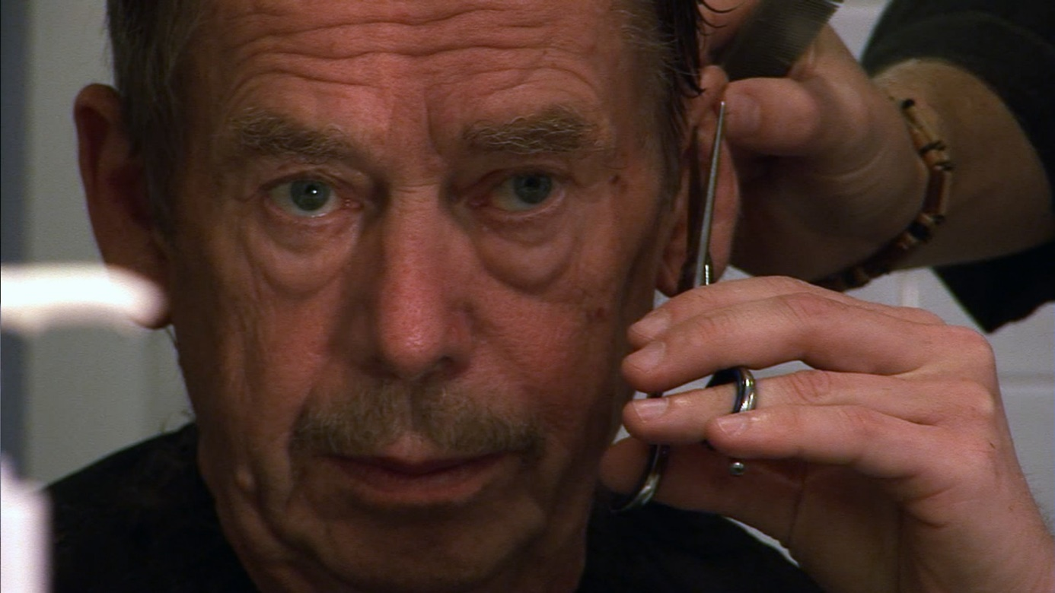
Havel Speaking, Can You Hear me? directed by Petr Jančárek

"I began working with Václav Havel in 2003. Our relationship was characterized by ultimate frankness and trust from Václav Havel's side and my absolute responsibility towards him. During the last years of Havel's life, over two hundred hours of unique, previously unpublished footage was produced, which became the basis for this feature-length documentary," says Petr Jančárek, who will introduce the film at the festival's grand opening, along with the film's producer Jiří Konečný and other creators. The film is part of the competitive Czech Joy section. The film was produced by Endorfilm in co-production with Essens Foundation, Michael Kocáb Foundation, Petr Jančárek and the Václav Havel Library with the support of the Czech Film Fund.

The Contribution to World Cinema Award goes to Béla Tarr

This year, the award for contribution to world cinema will be presented to the prominent Hungarian director Béla Tarr. His latest film, The Turin Horse (2011), was notably honored at the Berlinale festival with the grand jury prize, and many critics considered it the film of the year. “Béla Tarr's films are known to audiences literally all over the world, and they are often mentioned among the most significant films ever made. For many filmmakers, he is an inspiration and a master. For instance, in the 1990s, writer, theorist, and director Susan Sontag called him the saviour of contemporary cinema. While he initially made short documentaries, primarily about workers and marginalized individuals in Hungarian society, his later feature films are characterized by a distinct minimalist style, a sense of apocalypse, combined with a feeling for absurdity,” says the festival director Marek Hovorka. The Ji.hlava audience can look forward to Tarr's masterclass and a screening of his Werckmeister Harmonies (2000).
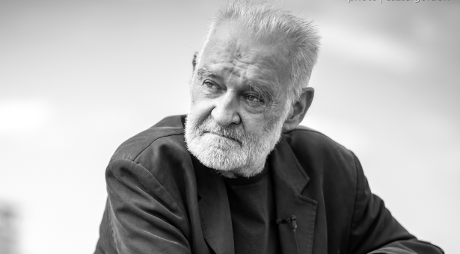
© Béla Tarr

Masterclass: Agnieszka Holland and Naomi Kawase

What else does this year's Ji.hlava have in store? For example, a masterclass by Polish director Agnieszka Holland on her debated drama Green Border (2023). "We all noticed the aggressive rhetoric of Polish politicians against Green Border from which we want to clearly distance ourselves and support the director in her artistic work. At the same time, we are interested in how this feature film, reflecting the current situation on the Polish-Belarusian border, was created, how director Holland transformed the vivid reality into a feature film, and in what ways this film remains a documentary," says Marek Hovorka.

After eighteen years, Japanese director Naomi Kawase will return to Ji.hlava with a masterclass. For over three decades, she has been one of the most prominent Asian filmmakers. Her documentary and feature films are characterized by their unique poetics and a sense for cinematic form and rhythm. Her work stands out for its empathetic portrayal of female protagonists and the themes they carry within.

The esteemed director was awarded the Contribution to Cinematography Award in Ji.hlava in 2005. Ji.hlava will showcase both her documentary and feature work. Her filmic take on the Olympic Games – the Official Film of the Tokyo 2020 Olympics – is a captivating spectacle rooted in Japanese cultural traditions. Also on the programme is her feature film Still the Water (2014), which delves into themes of adolescence and death."

Inspiration Forum calls to the table!

The Inspiration Forum discussion platform will once again provide an opportunity to discover new perspectives, strengthen dialogue, and introduce new questions about the contemporary world to the public space. This year's edition will focus on water, artificial intelligence, space, communities, and food.
On the very first day, the focus will be on food. “Food stands at the center of human communities and our lives, not only as a physiological necessity but also as an emotional, social, and political phenomenon. Food shapes us – by where we source it, how we consume it, and with whom we sit at the table,” says Tereza Swadoschová, the head of the Inspiration Forum. The programme promises a discussion on 'localism', in which journalist Petra Tajovsky Pospěchová, Ji.hlava politician and activist Eva Nováková, and farmer and founder of Biofarm Sasov will open up the topic of local ingredients: what prevents us from using them, why Czech restaurants do not cook locally, and how this approach works abroad.

Sustainable Ji.hlava

The Ji.hlava IDFF has long strived to be environmentally friendly. “To behave sustainably, to live without compromising the future of upcoming generations or others, means to assume collective responsibility,” says the festival, which introduced the role of an ecological ombudsperson five years ago. This ombudsperson consults on the festival's activities from a sustainability perspective; not just for the festival itself, but for all its year-round activities as well. “I am delighted that we are seeking ways to connect festival catering with local farmers with the aim of showcasing regional products from the Vysočina region. For me, this is a picture of a truly local solution to global challenges,” says Ji.hlava’s ecological ombudsperson, Soňa Klepek Jonášová. “Cooking with local ingredients, drastically reducing waste, or alternatively, utilizing food that would otherwise end up as waste. It might seem like a minor thing, but setting this entire initiative in motion took several months of work. And collaboration. And collaboration is a theme that will be evident in all the solutions Ji.hlava offers this year,” adds Jonášová. She mentions that the festival has set several priority areas for this year: waste, mobility, food, energy, and cooperation.

Festival food – local food!

The theme of food not only extends to the festival's programme but also to its organization. This year, attendees will have access to a map listing restaurants where vegan or vegetarian dishes are available. For this edition, Ji.hlava has also prepared an original recipe made from local and seasonal ingredients, which everyone can try cooking at home. Another new feature this year is special edible merchandise: renowned regional honey, jam, tea, and juices. Find more information about activities aimed at reducing the festival's carbon footprint here: http://www.ji-hlava.com/eko

The 27th Ji.hlava IDFF will take place on October 24–29, 2023. More information at www.ji-hlava.com and on the festival’s Facebook and Instagram profiles. Email contact: pressservice@ji-hlava.cz.

PARTNERS AND SPONSORS 2023

MAIN SUPPORTERS
Ministry of Culture Czech Republic
Czech Film Fund
Creative Europe MEDIA
Statutory City of Jihlava
Vysočina Region

MAIN PARTNER
Gemo

GENERAL MEDIA PARTNER
Czech Television

MAIN MEDIA PARTNER
Czech Radio

EXCLUSIVE MEDIA PARTNERS
Aktuálně.cz
Respekt

SUPPORTED BY
EEA and Norway Grants
International Visegrad Fund
U.S. Embassy in the Czech Republic
French Institute
ARRI
Current Time TV
National Recovery Plan financed by EU
NextGenerationEU / Ministry of Culture
Czech Centres
Italian Cultural Institute
Austrian Cultural Forum
Státní fond kultury
German Films
Delegation of Flanders in the Czech Republic
Instituto Camões
Unifrance
Jan Barta

PARTNERS OF THE INDUSTRY SECTION
Creative Europe MEDIA
Czech Film Fund
International Visegrad Fund
Ministry of Culture Czech Republic
Audiovisual Producers’ Association
Statutory City of Jihlava
Creative Europe Desk CZ – Media
Czech Film Center

PARTNERS OF JI.HLAVA NEW VISIONS AWARDS
AmDocs
Current Time TV
FilmAid
Cannes Docs - Marché du Film
Documentary Association of Europe
European Film Market
Soundsquare
UPP
#Docs Connect Taskovski Film Training

PARTNER PROJECT
Doc Alliance Films

THE INSPIRATION FORUM PARTNERS
Co-funded by European Union
EEA and Norway Grants
IOCB Tech Foundation
Prague office of the Heinrich-Böll-Stiftung
Friedrich-Ebert-Stiftung e.V. – Representation in the Czech Republic
Masaryk Democratic Academy
Slovak-Czech Women's Fund
Czech Centres
Creative Europe Desk Czech Republic
The Journalism Incubator

SUSTAINABILITY PARTNER
Co-funded by the EU’s Single Market Programme

REGIONAL PARTNERS
Citypark
Chesterton
Sepos
The College of Polytechnics Jihlava
WFG Capital

OFFICIAL SHIPPING PARTNER
FedEx Express

PHOTO PARTNER
Nikon

PARTNER OF VR ZONE
Go360
Broumov Development Agency

OFFICIAL FESTIVAL BEER
MadCat Brewery

OFFICIAL SUPPLIERS
Auto Dobrovolný
AZ Translations
BIOFILMS
Böhm
BOKS
Decathlon
Dřevovýroba Podzimek
E.ON
Fine Coffee
Flexipal
Husták
ICOM
Johannes Cyder
KINOSERVIS
KOMA Modular
La Formaggeria Gran Moravia
Leros
Little Urban Destillery
M-SOFT
Merch4u
Mitech
Next Bike
On Lemon
OnSinch
TENTino
Tierra Verde
Porta Bohemica Winery
We Are Ferdinand
Zahrady Laurus
Zmrzlina Snová

PARTNERS OF JI.HLAVA FOR KIDS
National Recovery Plan financed by EU
NextGenerationEU / Ministry of Culture
Vysočina Reginal Gallery
F POINT
RASL čalouněný nábytek
ČT:D
Brána Jihlavy
DAFilms Junior
Dětský lesní klub Hájenka
DIOD - Divadlo otevřených dveří
Nikon škola
Meruzalka-Montessori MŠ a ZŠ v Jihlavě
Rodinný park Robinson
Knihkupectví Dlouhá punčocha
UNiBON Production
Tirealis
LAGUS
Bistro na tři tečky
HUSTÁK CZ

CO-OPERATIONS
Aerofilms
Bombus Natural Energy
DIOD
DKO – Dům kultury a odborů Jihlava
Dopravní podnik města Jihlavy a.s.
Horácké divadlo Jihlava
Masaryk University
Cinema Máj in Třešť
Newton Media
Vysočina Regional Gallery
Prádelna a čistírna Jihlava

MEDIA PARTNERS
A2
A2larm
Dějiny a současnost
Film a doba
Radio 1

REGIONAL MEDIA PARTNERS
City.cz
Hitrádio Vysočina
Jihlavská Drbna
Jihlavské listy
Náš Region

MEDIA CO-OPERATIONS
25fps
ArtMap
ČSFD
Festival Guide
Full Moon
HIS Voice
Heroine
Host
Kinobox
Kult.cz
Nový prostor
Revolver Revue
Studio VOKO
7.G

INTERNATIONAL MEDIA PARTNERS
Variety
Cineuropa
Modern Times Review
Business Doc Europe
Kapitál
Kinema.sk
Kino Ikon

